ALKANOIC ACIDS [CARBOXYLIC ACIDS]

BEHAVIOUR OBJECTIVES
At the end of this lesson, students should be able to:
- outline natural substances containing alkanoic acids.
- classify alkanoic acid according to the number of -COOH present in their molecular structure.
- enumerate at least 3 physical and chemical properties of alkanoic acids.
- test for alkanoic acids.
- itemize at least 5 uses of alkanoic acids.
- define esterification.
- compare and contrast esterification and neutralization.

Alkanoic acids are compounds with general formula C_{n}H_{2n + 1} COOH, which contains carboxyl group, -COOH, as their functional group and n>= 0. Carboxyl group from carbonyl (C=O) and hydroxyl (-OH) It is named by replacing ‘e’ in Alkane with -oic acid. Alkanoic acids are also called ‘organic acid’ or ‘carboxylic acid’.

NATURAL SOURCES OF ALKANOIC ACID
Sources | Organic acid
Lemon  Apples  Milk  Tamarind  Vinegar  Tomatoes  Vinegar  Grapes, sour soup  Urea  Ants and bees | Citric acid  Malic acid  Lactic acid  Tartaric acid  Acetic acid (ethanoic acid)  Ascorbic acid  Acetic acid  Tartaric acid  Uric acid  Methanoic acid

CLASSIFICATION OF ALKANOIC ACID
Alkanoic acids can be classified based on the number of carboxyl group present per molecule.
Monocarboxylic acids: contains only one carboxylic acid per molecule. e.g. ethanoic acid, butanoic acid.
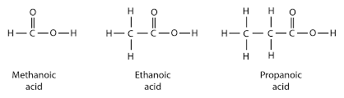

Dicarboxylic acids: contain two carboxyl groups per molecule. e.g. ethanedoic acid (oxalic acid), propanedioic acid (malonic acid).
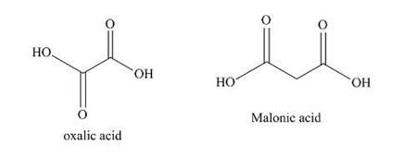

Tricarboxylic acids: contain three carboxyl groups per molecule. e.g. 2-hydroxy propane-1,2,3-tricarboxylic acid (citric acid).
CITRIC ACID
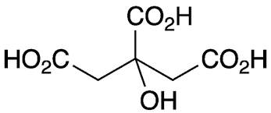

PHYSICAL PROPERTIES OF ETHANOIC ACID
- A colourless liquid with pungent smell.
- Very soluble in water.
- Boils at 118ºC, generally alkanoic acid have high boiling point and this due to hydrogen bonding.
- Turns blue litmus red.
- Dilute solutions have sour taste.

CHEMICAL PROPERTIES OF ETHANOIC ACID
- Reacts with electropositive metals to liberate hydrogen gas.
  - 2CH₃COOH_{(aq)} + Mg_{(s)} → (CH₃COO)₂Mg_{(s)} + H_{2(g)}

- Esterification: reacts with alkanol to give Alkanoate.
  - CH₃COOH_{(aq)} + CH₃CH₂OH_{(aq)} → CH₃COOCH₂CH_{3(aq)} + H₂O_{(aq)}

- Decarboxylation: removal of CO₂ from a molecule of alkanoic acid.
  - CH₃COOH_{(aq)} $NaOH \left(soda lime\right) →$ CH₄ + CO₂

- Reduction: carboxylic acid can be reduced to 1º alkanol using a reducing agent.
- CH₃COOH_{(aq)} + 4[H] $LAlH4→$ CH₃CH₂OH_{(aq)} + H₂O_{(l)}

PREPARATION OF ETHANOIC ACID
By the complete oxidation of ethanol using excess acidified potassium dichromate, [K₂Cr₂O₇] or potassium permanganate, [KMnO₄]. This process involves two stages;
STEP 1: Ethanol oxidized to ethanol.
CH₃CH₂OH +[O] → CH₃CHO + H₂O
STEP 2: Ethanol oxidized to ethanoic acid.
CH₃CHO + [O] → CH₃COOH

USES OF ETHANOIC ACID
- An important organic solvent.
- Used in food industry as vinegar for preserving and flavouring foods.
- Used in making compounds like ethyl ethanoate.
- Used for coagulating rubber latex.

DIFFERENCES BETWEEN ESTERIFICATION AND NEUTRALIZATION
We are familiar with neutralization reaction, that is the reaction between acid and base to give salt and water.
H₂SO_{4(aq)} + NaOH → Na₂SO_{4(aq)} +H₂O_{(l)}
Esterification is a reaction between an alkanoic acid and alcohol to give ester (Alkanoate) and water.
CH₃COOH_{(aq)} +CH₃OH_{(aq)} → CH₃COOCH₃ + H₂O_{(l)}
The main difference between esterification and neutralization reaction is that, esterification requires a catalyst to speed up the reaction, whereas, neutralization reaction does not require the use of catalyst.

DRILL QUESTIONS

- The reaction between alkanoic acids and alkanols in the presence of a mineral acid is known as ………….…?
- Saponification
- Hydrolysis
- Esterification
- Dehydration

- CH₃COOH_{(g)} → CH_{4(g)} + CO_{2(g)}
The reaction above is ………………...?
- Decarboxylation
- Carboxylation
- Acidification
- Methylation

- The intermediate product formed when ethanol is progressively oxidized to ethanoic acid with potassium heptaoxodichromate(VI) is ……………?
- Butanal
- Ethanal
- Methanal
- Propanal

- Citric acid appears in unripe orange while ethanoic acid appears in …………….?
- Unripe pawpaw
- Carrot
- Vinegar
- Milk

- Ethan-1,2-dioic acid is …………….?
- Mineral acid
- Soap
- Citric acid
- Dicarboxylic acid

ANSWER
- C
- A
- B
- C
- D

